
I am going to produce gold wasser, So i want to know detailed manufacturing process and chemical structure, material consistance.
Give me detailed data, source, image and so on
To produce Goldwasser, begin with macerating a complex blend of botanicals in high-proof neutral grain spirit, followed by sweetening, filtration, and addition of edible gold leaf flakes. Goldwasser’s “chemical structure” primarily refers to the ethanol base and suspended gold flakes, while the material consistency comes from carefully extracted herbal components, syrup, and gold.^{[1][2]}
Detailed Manufacturing Process
- Botanical Maceration: Place botanicals—Chinese and/or Ceylonese cinnamon, anise seeds, juniper berries, nutmeg, orris root, rosemary flowers, cardamom (both greater and lesser), coriander, ambrette seeds, cloves, fresh orange and lemon peels—into 85° neutral grain spirit for 24 hours.^{[1]}
- Filtration: Filter the macerated liquid to remove solid botanical matter.^{[1]}
- Sweetening: Add sugar syrup to create the signature liqueur base.^{[1]}
- Gold Leaf Addition: Dissolve or suspend edible gold leaf flakes in the sweetened, filtered liqueur. Edible gold is almost chemically inert and passes safely through the body, so use genuine food-grade gold leaf (22–23 karats) for authenticity.^{[3]}
- Blending and Bottling: Blend with additional flavor distillates if desired, then bottle the clarified liqueur. Most producers chill and filter again before packaging for clarity and consistency.^{[1]}
Example Botanical Mix (historical recipes):
- Cinnamon varieties (Chinese, Ceylonese)
- Orange and lemon peels
- Cardamom (Amomum subulatum, Amomum cardamomum)
- Juniper, coriander, ambrette seeds
- Nutmeg, anise seeds, rosemary flowers, lavender, thyme, cloves.^{[1]}
Chemical Structure and Material Consistency
- The chief chemical component is ethanol (ethyl alcohol, $ \mathrm{C_2H_5OH} $), from neutral grain spirit.^{[1]}
- Gold leaf is elemental gold (Au), inert in alcohol and water.^{[4]}
- Botanicals contribute trace essential oils and aromatic compounds; these include terpenes, flavonoids, and phenolic compounds, whose detailed structures depend on each herb added.^{[1]}
- Sugar syrup is typically sucrose dissolved in water.
Edible Gold Flake
- Use 22–23 karat food-grade gold leaf. This form of gold is exceedingly stable and used only for visual effect—gold does not react with alcohol or sugar solution.^{[4][3]}
Source Recipe Example
A classic 24-hour maceration can be followed by blending with syrup and gold leaf after filtration:
- 24-hour maceration: cinnamon, anise, juniper, nutmeg, orris root, rosemary, cardamom, clove, orange/lemon peel in spirit.
- Filter, sweeten with syrup, and add gold leaf.^{[1]}
Visual Reference
Here is a historical image of a bottle of Goldwasser liqueur.
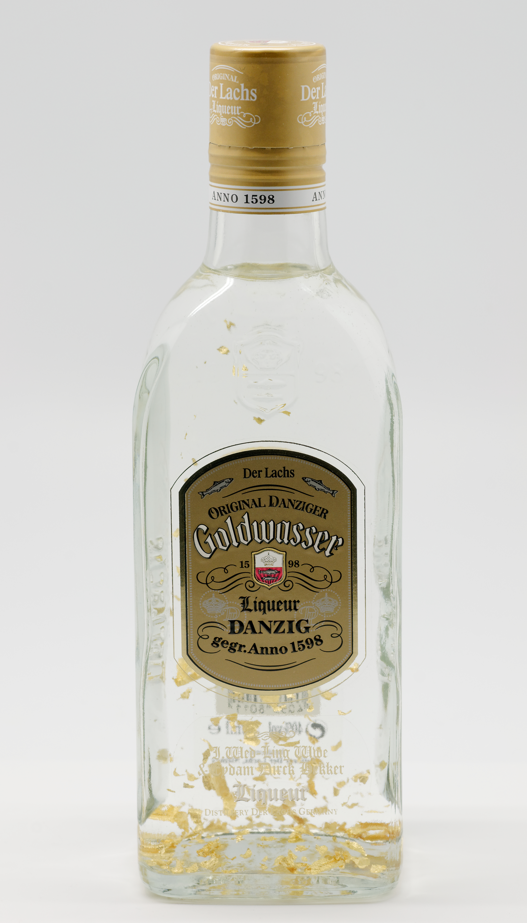
Original Danziger Goldwasser Liqueur by Der Lachs Co. with gold flakes, 40% Alc. by Vol., established 1598.
- Production and botanical composition:^{[1]}
- Ingredient details and edible gold:^{[2][3]}
- Chemical structure and gold properties:^{[4]}
If deeper chemical analysis or modern distillation standards are needed, share the specific target volume and desired flavor profile—process parameters can be further detailed or lab-grade procedures included.
⁂

- http://thehistorians-jaredbrown.blogspot.com/2014/06/lost-ingredients-danzigwasser.html
- https://foodsubs.com/ingredients/goldwasser
- https://en.wikipedia.org/wiki/Goldwasser
- https://en.wikipedia.org/wiki/Gold
- https://www.sciencedirect.com/science/article/pii/S2405844024035643
- https://www.911metallurgist.com/blog/gold-smelting-refining-process/
- https://www.youtube.com/watch?v=bUZ-Q2mqF5w
- https://pmc.ncbi.nlm.nih.gov/articles/PMC6643217/
- https://www.britannica.com/technology/gold-processing/Refining
- https://en.wikipedia.org/wiki/Vodka
- https://patents.google.com/patent/DE1149912B/en
- https://www.sciencedirect.com/science/article/pii/S0753332223007801
- https://propaganda24h.pl/en_US/p/ORIGINAL-DANZIGER-GOLDWASSER-LIKIER-0,5L/1015
- https://dockchemicals.com/solutions/product-finder/
- https://www.youtube.com/watch?v=xsjnZml1TjQ
- https://www.911metallurgist.com/blog/gold-extraction-recovery-processes/
- https://www.eastcarb.com/gold-manufacturing-process/
- https://en.wikipedia.org/wiki/Wohlwill_process
- https://pmc.ncbi.nlm.nih.gov/articles/PMC3497048/
- http://adultbar.com.au/cocktails/How-To-Make-A/Goldwasser
- https://www.cdocast.com/induction_blog/the-complete-manufacturing-process-of-1mm-gold-and-silver-wire-from-casting-to-precision-drawing/

